Assignment 2- Case Study

Stage 3 Lab Activities

SmartCare Domain Modelling
AI OFF -> AI ON -> COMPARE -> VERIFY | 1 hour

A - Requirements Review
Highlight nouns, verbs and business rules in SmartCare v0.2.
Nouns:
- Patient
- Doctor
- Management
- SmartCare Community Clinic Staff Member
- Hospital
Verbs:
- Create
- Store
- Retrieve
- View
- Sort
- Delete
- Edit
- Search
Business rules:
- Only collect and store data that is required for the system to work
- Uphold data security and have safe data management systems in place

B - Candidate Classes
Record candidate concepts, supporting requirements, state and behaviour.

C - CRC Cards
Create CRC cards for Patient, Practitioner and Appointment.

Patient
Responsibilities | Collaborators
Check if they have an appointment scheduled | Practitioner
Check if they are available for an appointment | Appointment

Practitioner
Responsibilities | Collaborators
Check if they have an appointment scheduled | Patient
Check if they are available for an appointment at a certain time | Appointment

Appointment
Responsibilities | Collaborators
Check if patient and practitioner are available | Patient
Calculate appointment cost (if any) | Practitioner

D - UML Model
Draw classes, attributes, operations, associations and multiplicities.
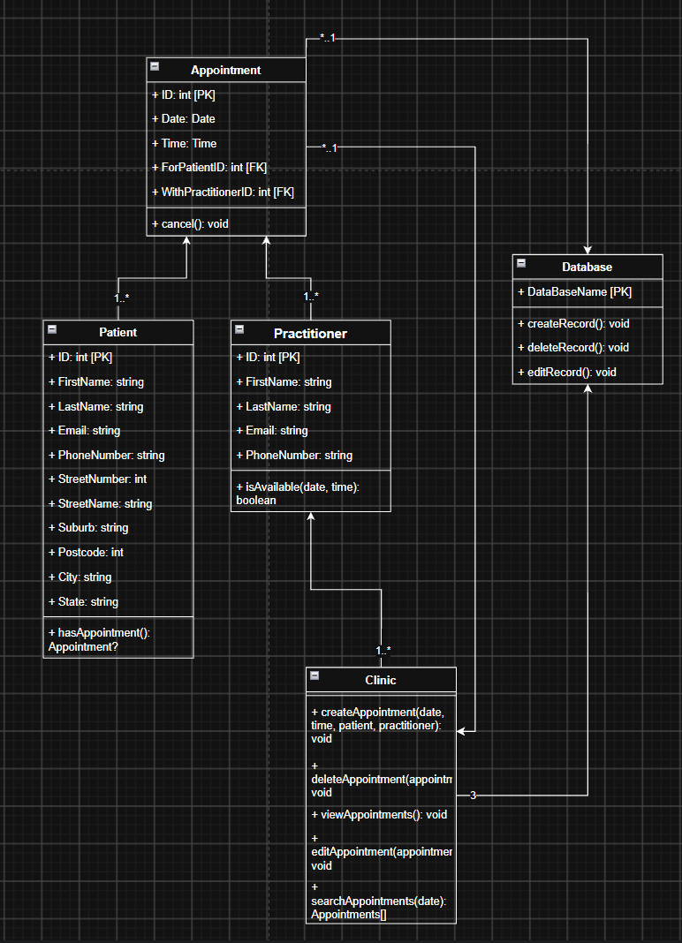

E - AI Design Review
Ask AI to suggest classes and relationships using only confirmed requirements; require supporting requirement IDs.

F - Compare and Decide
Record at least one accepted, modified and rejected AI suggestion.

G - Python Skeletons
Create simple Patient, Practitioner and Appointment class skeletons.
class Patient:
def __init__(self, firstName, lastName, email, phoneNumber, streetNumber, streetName, suburb, postcode, city, state):
self.id = 0
self.firstName = firstName
self.lastName = lastName
self.email = email
self.phoneNumber = phoneNumber
self.streetNumber = streetNumber
self.streetName = streetName
self.suburb = suburb
self.postcode = postcode
self.city = city
self.state = state

def hasAppointment():
pass

class Practitioner:
def __init__(self, firstName, lastName, email, phoneNumber):
self.id = 0
self.firstName = firstName
self.lastName = lastName
self.email = email
self.phoneNumber = phoneNumber

def isAvailable(date, time):
pass

class Appointment:
def __init__(self, date, time, forPatient, withPractitioner):
self.id = 0
self.date = date
self.time = time
self.forPatient = forPatient
self.withPractitioner = withPractitioner

def cancel():
pass

class Clinic:
def createAppointment(date, time, patient, practitioner):
pass

def deleteAppointment(appointment):
pass

def viewAppointments():
pass

def editAppointment(appointment, date, time, forPatient, withPractitioner):
pass

def searchAppointments(date):
pass

class Database:
def __init__(self, dataBaseName):
self.dataBaseName = dataBaseName

def createRecord():
pass

def deleteRecord():
pass

def editRecord():
pass

H - Consistency Check
Check model-code consistency; do not implement full behaviour yet.

Reflection
What modelling decision was hardest? Where did AI over-design? What evidence supported your final choices?

